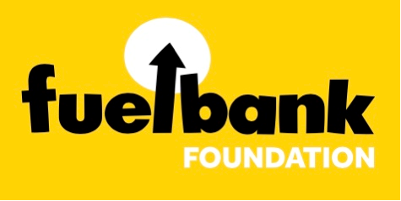
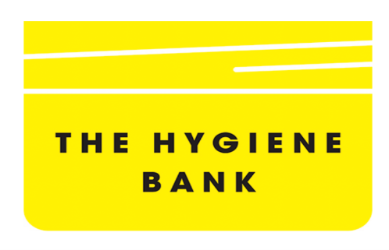
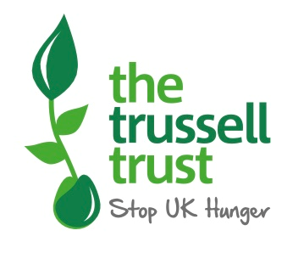
We have some exciting News!!!

We have now Partnered with
The Trussell Trust
Fuelbank Foundation
The Hygiene Bank

Please pop in and see Sam if you want any information on these and how she can help you and your family.

