Basic IT course (adults)
Let’s get you started learning some basic IT skills
4-sessions course running here at Miskin Primary School
Tuesday 21st & 28th March & 18th & 25th April
1-3pm
Interested? Come and have a chat with Sam, and book your place.
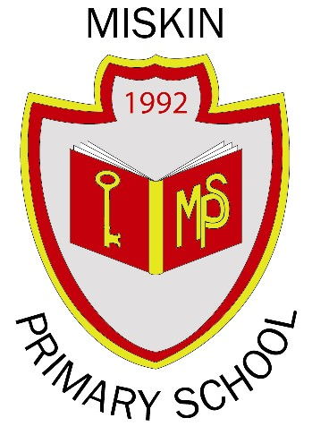

Monday 6th, 13th March 9:30pm – 2:30pm
Darran Las Community Building Aberdare Road Mountain Ash CF45 3PT
Ffôn/Telephone: 07795391852 Jill
Ebost/Email: jill.davies@rctcbc.gov.uk

