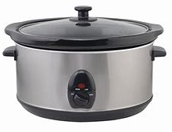
4 Week Slow Cooker Course

Wednesdays 9:30 – 11.30 a.m.
19th & 26th April
3rd & 10th May

These sessions show you how to prepare healthy meals for families using slow cooker recipes.
Complete the course and at the end of the course you will be able to take the slow cooker home.

Interested?
Come and have a chat with Sam and book your place.



