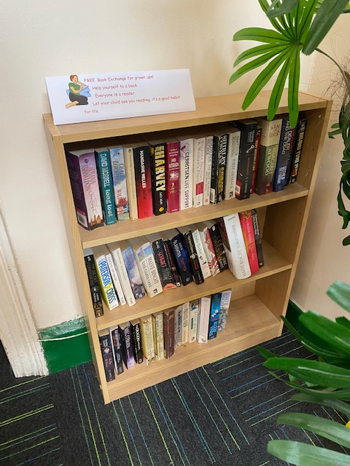
Welcome to our Book Exchange, this is available to all our ‘grownups’ please come along and grab any book you fancy from the corridor by the office. It is good for children to see adults enjoying a book! Develop a good habit for life.

