

Nursery Handbook

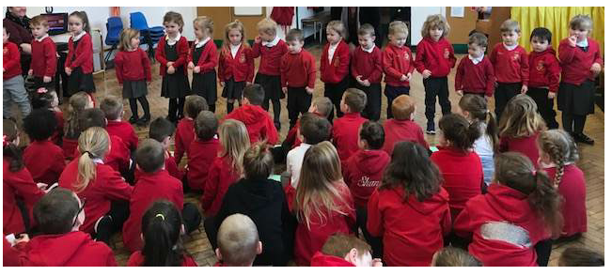

Dear Parents/ Carers,

The Governors, pupils and staff would like to welcome your child and your family to our Nursery at Miskin Primary School.

Now that your child has been accepted into the Nursery of our school, you will want to prepare them for the time when they start.

This booklet is designed to answer some of the questions that we are often asked and also to help with that essential preparation and runs alongside the school Prospectus.

The skills that we describe are the very foundations of much learning that comes later, and so until these are grasped, a child is not ready to progress to more complex tasks such as reading, writing and working with numbers. If you can teach and support your child to do as many of the things as possible in this booklet, they will be ready to learn to read and write. When they come to school, confidence will grow and working habits can quickly become established. It is important to note that not every child develops at the same rate and it is crucial that all children are valued for themselves at their current stage of development.

If you need advice on anything contained in this booklet, or anything else we can help you with, please do not hesitate to contact the Nursery staff or myself.

I look forward to meeting all new parents and carers in due course along with your marvelous children.

Best wishes,

Mrs. Fran Davies

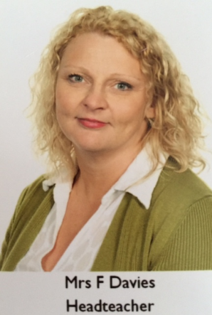

A warm welcome/ Croeso

At Miskin Primary School we strive to provide a welcoming, happy and safe environment where the children feel safe, secure and enjoy their learning experiences.

Our belief is that: ‘Our school exists for its pupils to enjoy their todays and prepare for their tomorrows’

We realise how precious your child is, so we aim to make the transition from home to school as smooth as possible. We acknowledge the support that parents give to the school and value this partnership. If there is anything worrying you or your child, please do not hesitate to share the concern with us.

Contact us

Our address: Miskin Primary School
York Street
Miskin
Mountain Ash
Rhondda Cynon Taff
CF45 3BG
Our telephone number: 01443 476426
E-mail address: admin@miskinprimary.rctcbc.cymru

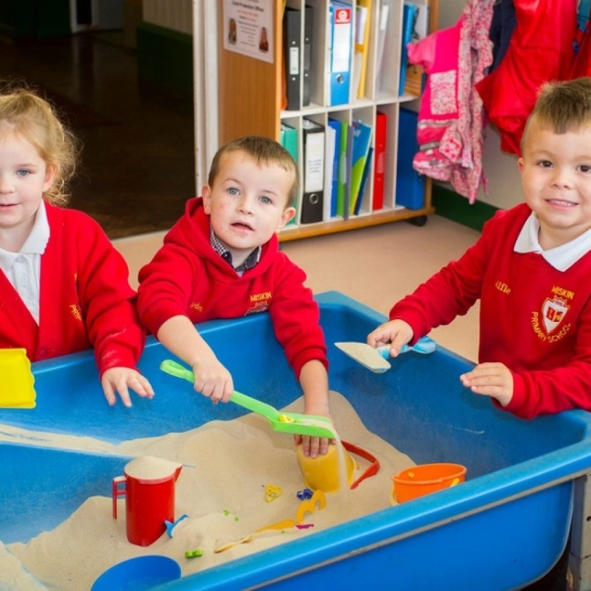

Nursery Times

9.00am – 3.15pm

The nursery doors open at 9am and children will be met by nursery staff.
Pupils arriving late will be awarded a late mark on the register. Please make every effort to be on time as this forms good habits for the future. Our Family Liason Officer Sam is here to help and support you in anyway she can.
We realise that there will be times when friends and family pick up your child from school. To safeguard our pupils we would appreciate it if you could inform us if someone different is collecting your child in advance.

Induction

Your child will be admitted to our Nursery the term after he/she becomes 3 years old. A date for your child to start nursery will be given and we will contact you for link up visits before they start. We operate a graduated intake to allow children to settle, pupils will stay from 9am – 10am for the first session with a view to building up this time to full days as soon as possible, but at a pace that your child is happy with.

School Clothing

All children are expected to wear school uniform:

Uniform: grey skirt/ pinafore/trousers/ joggers
white/red polo shirt
red school jumper/cardigan

Summer Uniform: red gingham dress / grey shorts
or as above

P.E kit: No kit required during time in Nursery

Please ensure that all items of clothing are labelled with your child’s name. In nursery class, jogging bottoms might be an easier option so that your child can cope more easily with independent toileting.

Due to the nature of the Foundation Phase curriculum, your child is unlikely to remain clean following painting, water and outdoor play activities. (Thank goodness for washing machines!) Try not to worry, just be assured that your child has been engaged in high quality learning experiences. (Cool wash is better for paint.)

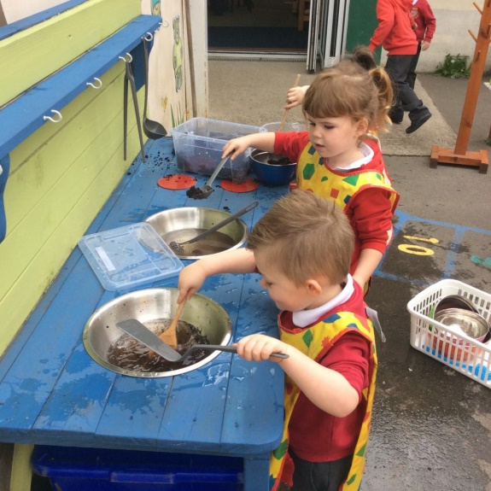

Health and Illness

In the case of absence, please telephone the school by 9.00am and leave a message; we can then inform the class teacher.

For the health and well-being of children and staff, please keep your child at home if he/she is unwell.
Please report in anything contagious so we can inform other parents if necessary.

Please note: Children with sickness/diarrhea must be well for 48 hrs before they return to school.

If your child becomes unwell at school, we will contact you so that he/she can be collected from school. Please complete the emergency contact numbers form and ensure they are kept up to date if you have a new phone.

As a matter of procedure we also always ring to inform you if a child has had a bump to the head.

The Foundation Phase

Our curriculum offers children opportunities to be creatively involved in their own learning which builds on what they already know and can do, their interests and what they understand. Active Learning enhances and extends children's development.

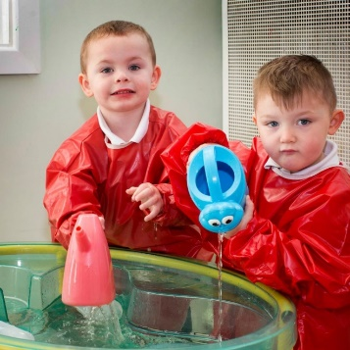

How can I help my child?

- Encourage them to be independent

Please show your children how to dress and undress themselves, put on their coats and shoes, and fasten them independently - velcro is a wonderful invention!

Teach them to use the toilet independently, always reminding them of the rules of hygiene.

Please help them to use a knife and fork correctly.

Please encourage your children to put away their toys when they have finished with them. This is an integral part of school life and needs to be undertaken by all children

All this helps to save time and allows staff to maximise on the pupils' learning time.

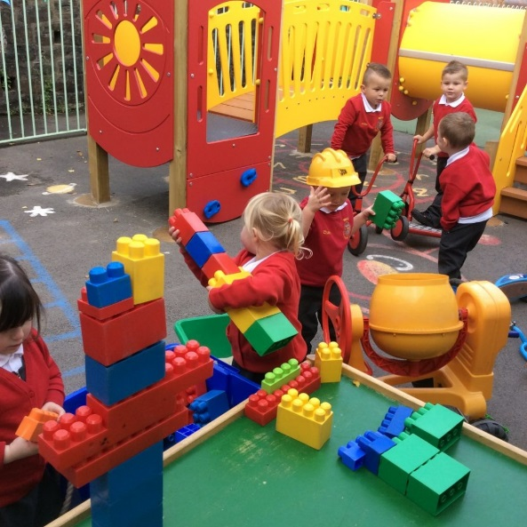

2. Play with a purpose

All children benefit from play. It is through play that they learn about themselves and the world in which they live. Play is about children learning through perseverance, attention to detail, and concentration - characteristics usually associated with work. Play is not only crucial to how children become self-aware and the way in which they learn the rules of social behavior; it is also fundamental to intellectual development.

Through play children learn the skills of:
- Listening
- Talking
- Co-operating
- Sharing
- Investigating
- Imagining

3. Communication skills

It is important that children are immersed in a range of language experiences and activities. This will promote listening, communicating and talking skills.

Talk about different things with your child e.g.
- Relate the events of the day.
- Daily routines - getting up, having breakfast etc.
- What you see when you go out e.g. shops, people, countryside etc.
- Ask them questions to encourage them to think.
- Discuss stories read, programs watched or tapes/stories listened to.
- It is also important that children acquire good listening skills so encourage them to listen carefully asking questions about what they have heard.
- Listen to and carry out simple instructions.
- Learn nursery rhymes off by heart. Nursery rhymes are so valuable, they help children identify rhyming words which are helpful when learning to read, encourage memory skills and develop imagination and vocabulary.
- Help your child to speak in sentences. This will help them to read more fluently and think more clearly.

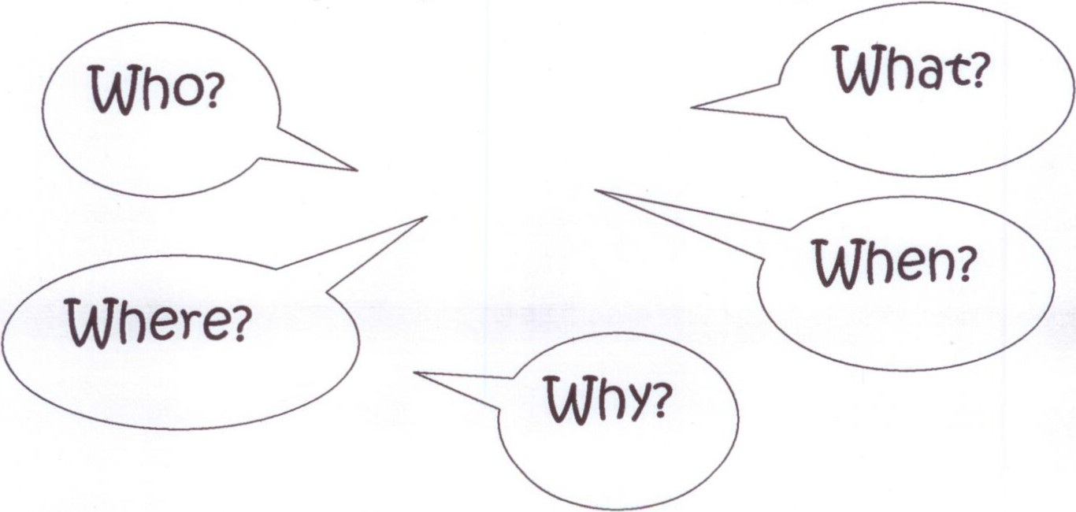

How can I help my child to write?

- Activities involving play dough, clay, plasticine and pastry help little fingers to pull, push, squeeze and grip. Games which use small beads and counters help to develop well trained muscles in the hand which are essential when learning to write.

- Encourage your child to make patterns and shapes using whole hand and fingers in materials such as washing up liquid, foam, sugar or salt. Action songs and rhymes that involve using arm, hand and wrist actions also help children to become fluent comfortable and legible writers.

- Painting with large and small brushes helps to train the eye and hand to work together and, of course, develops creative skills and imagination. Children often prefer to paint/draw standing rather than sitting so allow your child different opportunities to explore painting/drawing seated or stood. You can even paint with water onto dry concrete!

- Colouring, tracing and drawing help a child to make a pencil go where they want it to and as such they will soon develop a comfortable and natural pencil grip.

- When your child shows any interest in writing his/her name, please ensure they do so using a capital letter only for the first letter in the name.

- Help your child to use scissors correctly!

- Please encourage your child to hold scissors with their thumb on the top.

- Ensure that the scissors are not blunt and round ended scissors are safer than pointed ones. Left handed children need opportunities to use left handed scissors which are always at hand within the classroom.

- Catalogues, newspapers, old cards and magazines are ideal for cutting up. Cut outs can be sorted into shapes, colours, similar items etc. and pasted onto a sheet of paper.

- Reading - How you can help

Share a book with your child whenever you can:

- Make it a friendly and enjoyable time for both you and your child.
- Sit in a comfy chair or on the bed.
- Encourage them to handle books with care and respect.
- Let them find the beginning and end of the story so they can learn to handle books correctly.
- Talk about the pictures in the book.
- Tell them the story.
- Point to the words as you read.
- Let them tell you the parts they enjoyed from the story.
- Encourage them to join in with repetitive parts to the story.
- Let them choose their own books.
- Re-read favourite stories.
- Read and learn nursery rhymes and songs together.
- When reading ask them to look for letters that they might recognise in the words or letters that are in their own names.

In the Nursery we develop language skills through a variety of Speaking and Listening activities. We will also introduce the Read Write Inc. scheme by introducing sounds through a ‘hear it, say it, read it, write it’ approach. Resources and support for helping you with this are available online or please visit our website: www.miskinprimary.com

Other helpful activities

- Games involving looking at shapes can help, so look for shapes around them e.g. shapes of furniture, food, on vehicles etc.

- Games such as jigsaws, matching games, lotto, sorting games, board games all foster good memory skills as well as turn taking, communication and co-operating skills.

- Water and sand play will develop an understanding of materials, capacity, weight etc. Talk about floating, sinking, pouring, filling, emptying, shaping and forming.

- Play memory games with your child, for example - I spy with my little eye – when you play such games remember to use sounds of letters as well as letter names e.g. leg begins with 'l' and not 'ell'

- Help your child to learn their alphabet sounds – At Miskin Primary School, we use the Read Write Inc. scheme to teach letter sounds.

- Children have access to class computers, interactive whiteboards and I Pads and laptops on a daily basis and benefit by using the mouse/ keyboard/touch as well as communicating whilst working together. We use technology as an aid to learning however social interaction is essential. Please be mindful of how much time your child uses on devices and never before bed.

- Maths - How you can help

- Help your child by playing games such as sorting objects:
Put the cows, horses, chickens together
Sort the red crayons from the blue crayons

- Recognise and name the different colours.

- Recite and sing number rhymes and songs.

- Help them recall a simple sequence of events in their day.

- Numbers are everywhere around our homes and in the local environment – help your child identify them.

- At home or out and about, look at the surface of shapes and ask your child what shape is this plate, mirror, bath mat, window, door, traffic light etc.

- Other activities such as:

How many letters came through the door today?
Can you put a spoon by each bowl?
How many chairs are in this room?
How many apples are in the bowl?
How many steps do we have to climb?
Can you pass me 4 socks?

Remember to count objects of different types and in different arrangements. It is more important that a child knows that 3 can be 3 cows or 3 apples rather than being able to write it.

Thinking skills

Thinking skills are an important part of the Foundation Phase, and develop a child’s independence. Daily teaching activities are planned to encourage and allow children to think and learn in a variety of ways.

Children will be involved in many well planned activities to help expand and stretch their thinking skills. Games and activities are designed to improve children's ability to solve problems - a skill that they will be able to apply to many aspects of their work across the Foundation Phase and beyond. The activities encourage children to explain their reasoning, to listen and to interact with one another and to become better communicators - a skill that enhances both social and intellectual development.

Golden Rules to help the Nursery Staff

- Talk to your child positively about school and how much they will enjoy being in school.

- Clothing - please ensure all clothes are labelled including coats, shoes, jumpers etc. If children can put on/take off their own coats and dress/undress themselves with increasing independence this is also a tremendous help to teachers!

- The nursery will provide a daily mid-morning snack for all children at the cost of 50p per week per child, payable weekly, half termly or termly. We aim to give variety and promote healthy eating by including toast or fruit choices. We also provide opportunities for children to take part in cooking activities. Free milk will be provided each day. You are also welcome to send a named water bottle, which the children can refill at the water cooler, especially useful in the summer term.

- Outdoor play is an essential part of your child’s development. Please ensure your child has warm clothes and wellies in the colder months and a hat and sun cream in the summer. Please apply sun cream before school during warmer weather. We have full body water proof suits for pupils to use over their coats during some outdoor sessions.

- Permission form for photographs, school website, twitter, Facebook page etc will need to be completed. You will receive one of these from the school office. The permission will run for the time that your child is with us in Miskin Primary. If there are any changes then you must inform us in writing please. We will never use your child’s full name or use a photo with their name.

- Support your child in the early morning activities for the first 10 minutes of the day.

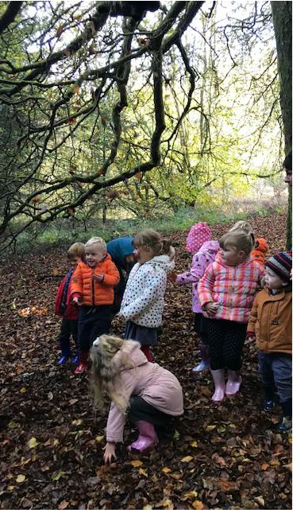

Please tell us about your child
Please complete the questions below and return to your child’s teacher.
- Describe your child’s personality in a few words.

- What do they like to do most of all?

- When they are playing with their toys inside what do they play with the most?

- When they are playing outside what do they like to play with and do the most?

- What is their favourite; Story

Film/DVD/app

Nursery Rhyme

Television programme

- How do they react when they are unhappy?

- Is your child afraid of anything or nervous around anything?

- Tell us about your child’s sleep patterns; do they sleep well and get a good night’s rest?

- What kind of food do they enjoy? Do they eat a wide range of foods? Do they like fruit and drink water?

- Does your child have any allergies?

- When did they begin to crawl; walk?

- Would you say that your child has good concentration skills?

- Have they got a special friend who they play with?

- Who (what) lives at home with you?

- Do you have any concerns that we should know about?

Thank you for taking the time to complete this questionnaire; it will help us to get to know your child and settle them quicker into the routines of school life. We want them to be happy learners.

