 Tips for supporting your child in learning their Times Tables
Mastering times tables is a vital skill that children must learn as soon as possible, in order to be confident in math. So it is really important that parents/carers try to find fun ways to teach times tables. We hope these tips will support you to support your child.

1. Hang up a times table sheet like this one-
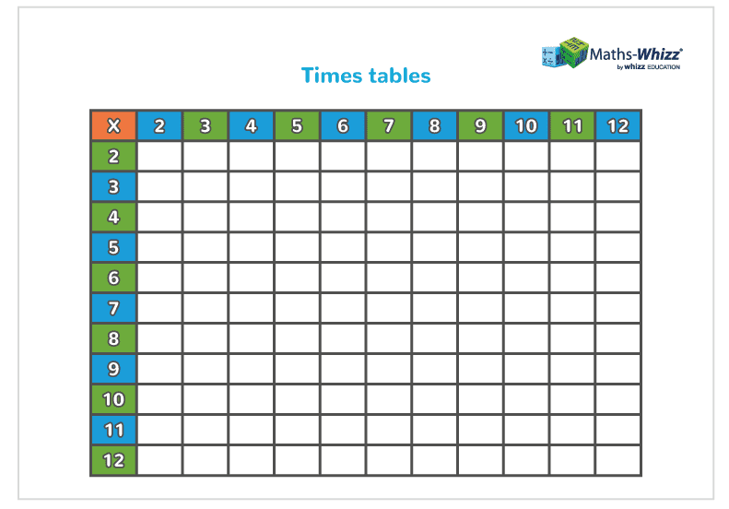
This is an old technique but it’s very effective. Once that’s done, go through it with your child, filling in each individual box together. Next step is to hang the completed chart up in a place where your child will see it regularly (e.g. their bedroom door, the fridge door, the cupboard next to the computer). Finally set a regular time for both you and your child to sit down and have a casual, no pressure run through of a particular set of times tables, perhaps just before dinner. Remember, the more often they see and practice their times tables, the more likely they are to learn them.

2. Make sure they can walk before they can run
We feel that the best order in which to teach the times tables is preferable to start with 2, 5 and 10, as the patterns within them are easier for children to grasp. Children are introduced to counting in multiples of 2, 5 and 10 first. Once secure and accurate with their recall of the tables, the easier it is to turn it into times table and see the structure and patterns that are present. Two times table involves doubling and using fingers initially can help children see and feel the symmetry of the doubling concept. In the 2 and 10 times tables the numbers are all even. In fact, any number multiplied by an even number will be even. Saying the 10 times tables helps children to see the patterns “…6 tens are 60, 7 tens are 70…”. With the 10 times table all the numbers end in 0 and in the 5 times table all the numbers end in 5 or 0. Once they have mastered the 2, 5 and 10 times tables, children should find it easier to move on to 4 and 8.

3. Teach your kids some tricks
One of the great things about maths is that it’s full of tips and tricks – and times tables are no different. Our favourite trick involves using your fingers to figure out nine times tables. Start by spreading all 10 fingers in front of you. To figure out 9×1, put your left pinky down. What are you left with? 9 fingers! For 9×2 put your left ring-finger down. What are you left with? 1 finger and a gap followed by 8 fingers or 18. This trick works up to 9×9 (8 and 1 or 81). That said, when teaching children these tricks, encourage them to ask why these techniques work and the mathematical reasoning behind them.

4. Listen to some fun songs
What’s a great way to get information stuck in someone’s head? Yep, that’s right! Catchy music! We use this CD in school, it is available on amazon if you wish to purchase.
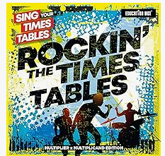
We also recommend checking out videos made by Youtuber, Mr.DeMaio, a school teacher who uses clever parodies of pop songs to teach kids their times tables. Our favourite is definitely his cover of Uptown Funk which aims to teach children their three times tables.

5. Play with numbers eg. ‘Gringo Bingo’

Players set out an 8 or 12 square grid on a piece of paper.

(Example for x5,x10 tables)
5 | 15 | 100 | 45
10 | 15 | 20 | 25
50 | 35 | 55 | 30

fill in the squares with answers of the tables you are learning. One person calls out the calculations, if the answer is on your bingo grid you can cross it out, the first player to cross off all their numbers is the winner.

There are also card games and online games that you can access too.

6. Draw a Waldorf multiplication flower

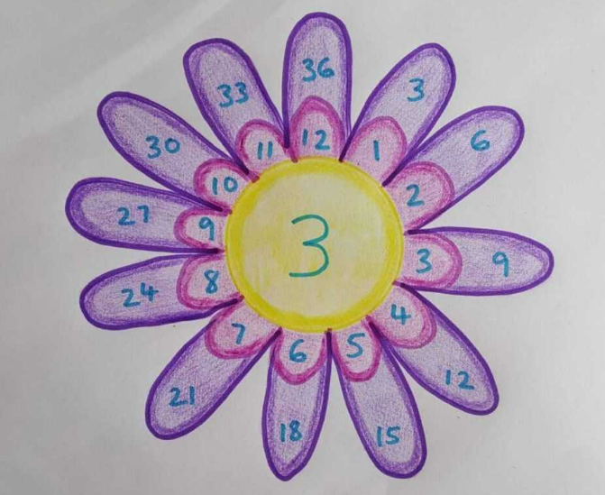
One for the creative kids! Children start this activity by drawing the centre of the flower, in which they write a number between 2 and 12. They then draw 12 petals around the centre, with each petal containing the numbers 1 through 12. The last step is to draw another set of 12 petals which contain the centre number multiplied by each petal in the inner circle.

7. Quiz them often, but don’t make it a task
Once you think your child is getting the hang of their times tables, it’s time to put them to the test. It’s best to do this is when there’s nothing else really going on, like while you’re walking them to school or while you’re waiting for a bus. Also, try to normalise these drills by allocating a specific time of the week to quiz them, rather than springing it on them randomly, that way the drills aren’t too stressful.

8. Reward their efforts
When encouraging children to pursue something important, like timetables, there’s no harm in heightening their enthusiasm with a little reward. Remember that you shouldn’t just reward your child for getting answers right, though. Don’t be afraid to give them a treat if you can see they’ve been trying hard but haven’t quite mastered their times tables yet. This encourages persistence. Also, remember not to judge them if they get the answers wrong, learning should always be an enjoyable experience!

